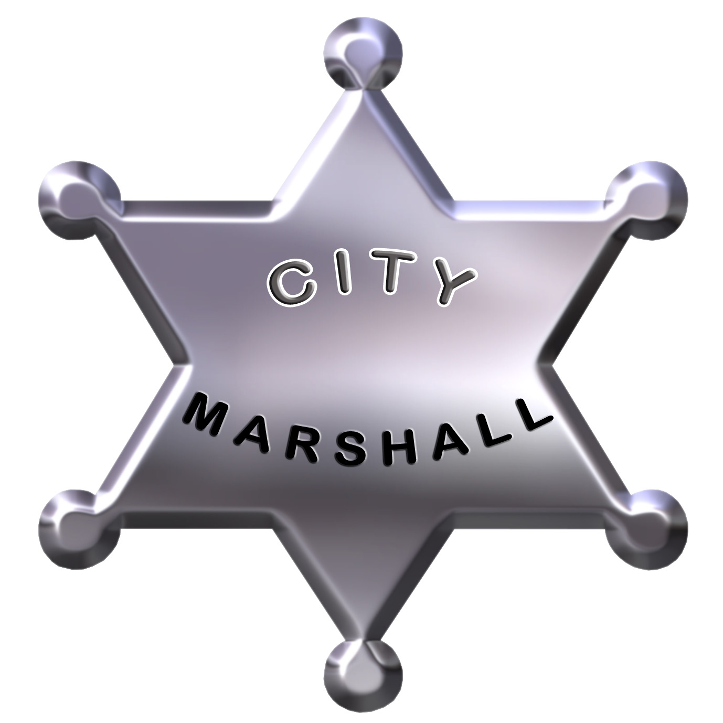
Voted Best Therapeutic Massage in Wales - World Spa Awards

B Best Complementary Therapy in UK from over 14,000 practices

CONSULTATION FEES

FEES ARE CHARGED PER TIME YOU REQUEST:

30 minute treatment £70 75 minute treatment £125

45 minute treatment £85 90 minute treatment £150

60 minute treatment £100 120 mins treatment £180

T R E A T M E N T S
(ALL NEW CLIENTS RECEIVE A FREE 15 MINUTE CONSULTATION)

◊ SPORTS MASSAGE THERAPY / DEEP TISSUE MASSAGE and / or
◊ JAPANESE SHIATSU ACUPRESSURE / THAI YOGA MASSAGE and / or
◊ SWEDISH BODY MASSAGE / LYMPHATIC DRAINAGE / DETOX and / or
◊ INDIAN HEAD MASSAGE / HOLISTIC FACIAL MASSAGE and / or
◊ REIKI CHAKRA BALANCING / HEALING / CRYSTAL THERAPY and / or
◊ CLINICAL REFLEXOLOGY / THAI FOOT MASSAGE and

U P G R A D E S @ £15 each

◊ HOPI EAR CANDELING
◊ HOT STONES THERAPY
◊ HOT THAI HERBAL COMPRESS
◊ AROMATHERAPY PERSONALISED OIL BLEND
◊ AROMATHERAPY EXFOLIATING BODY BRUSH
◊ AROMATHERAPY FOOT SPA
◊ AROMATHERAPY BODY WRAPS or FACE MASK

