Luxury Mercedes Viano


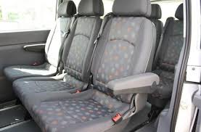
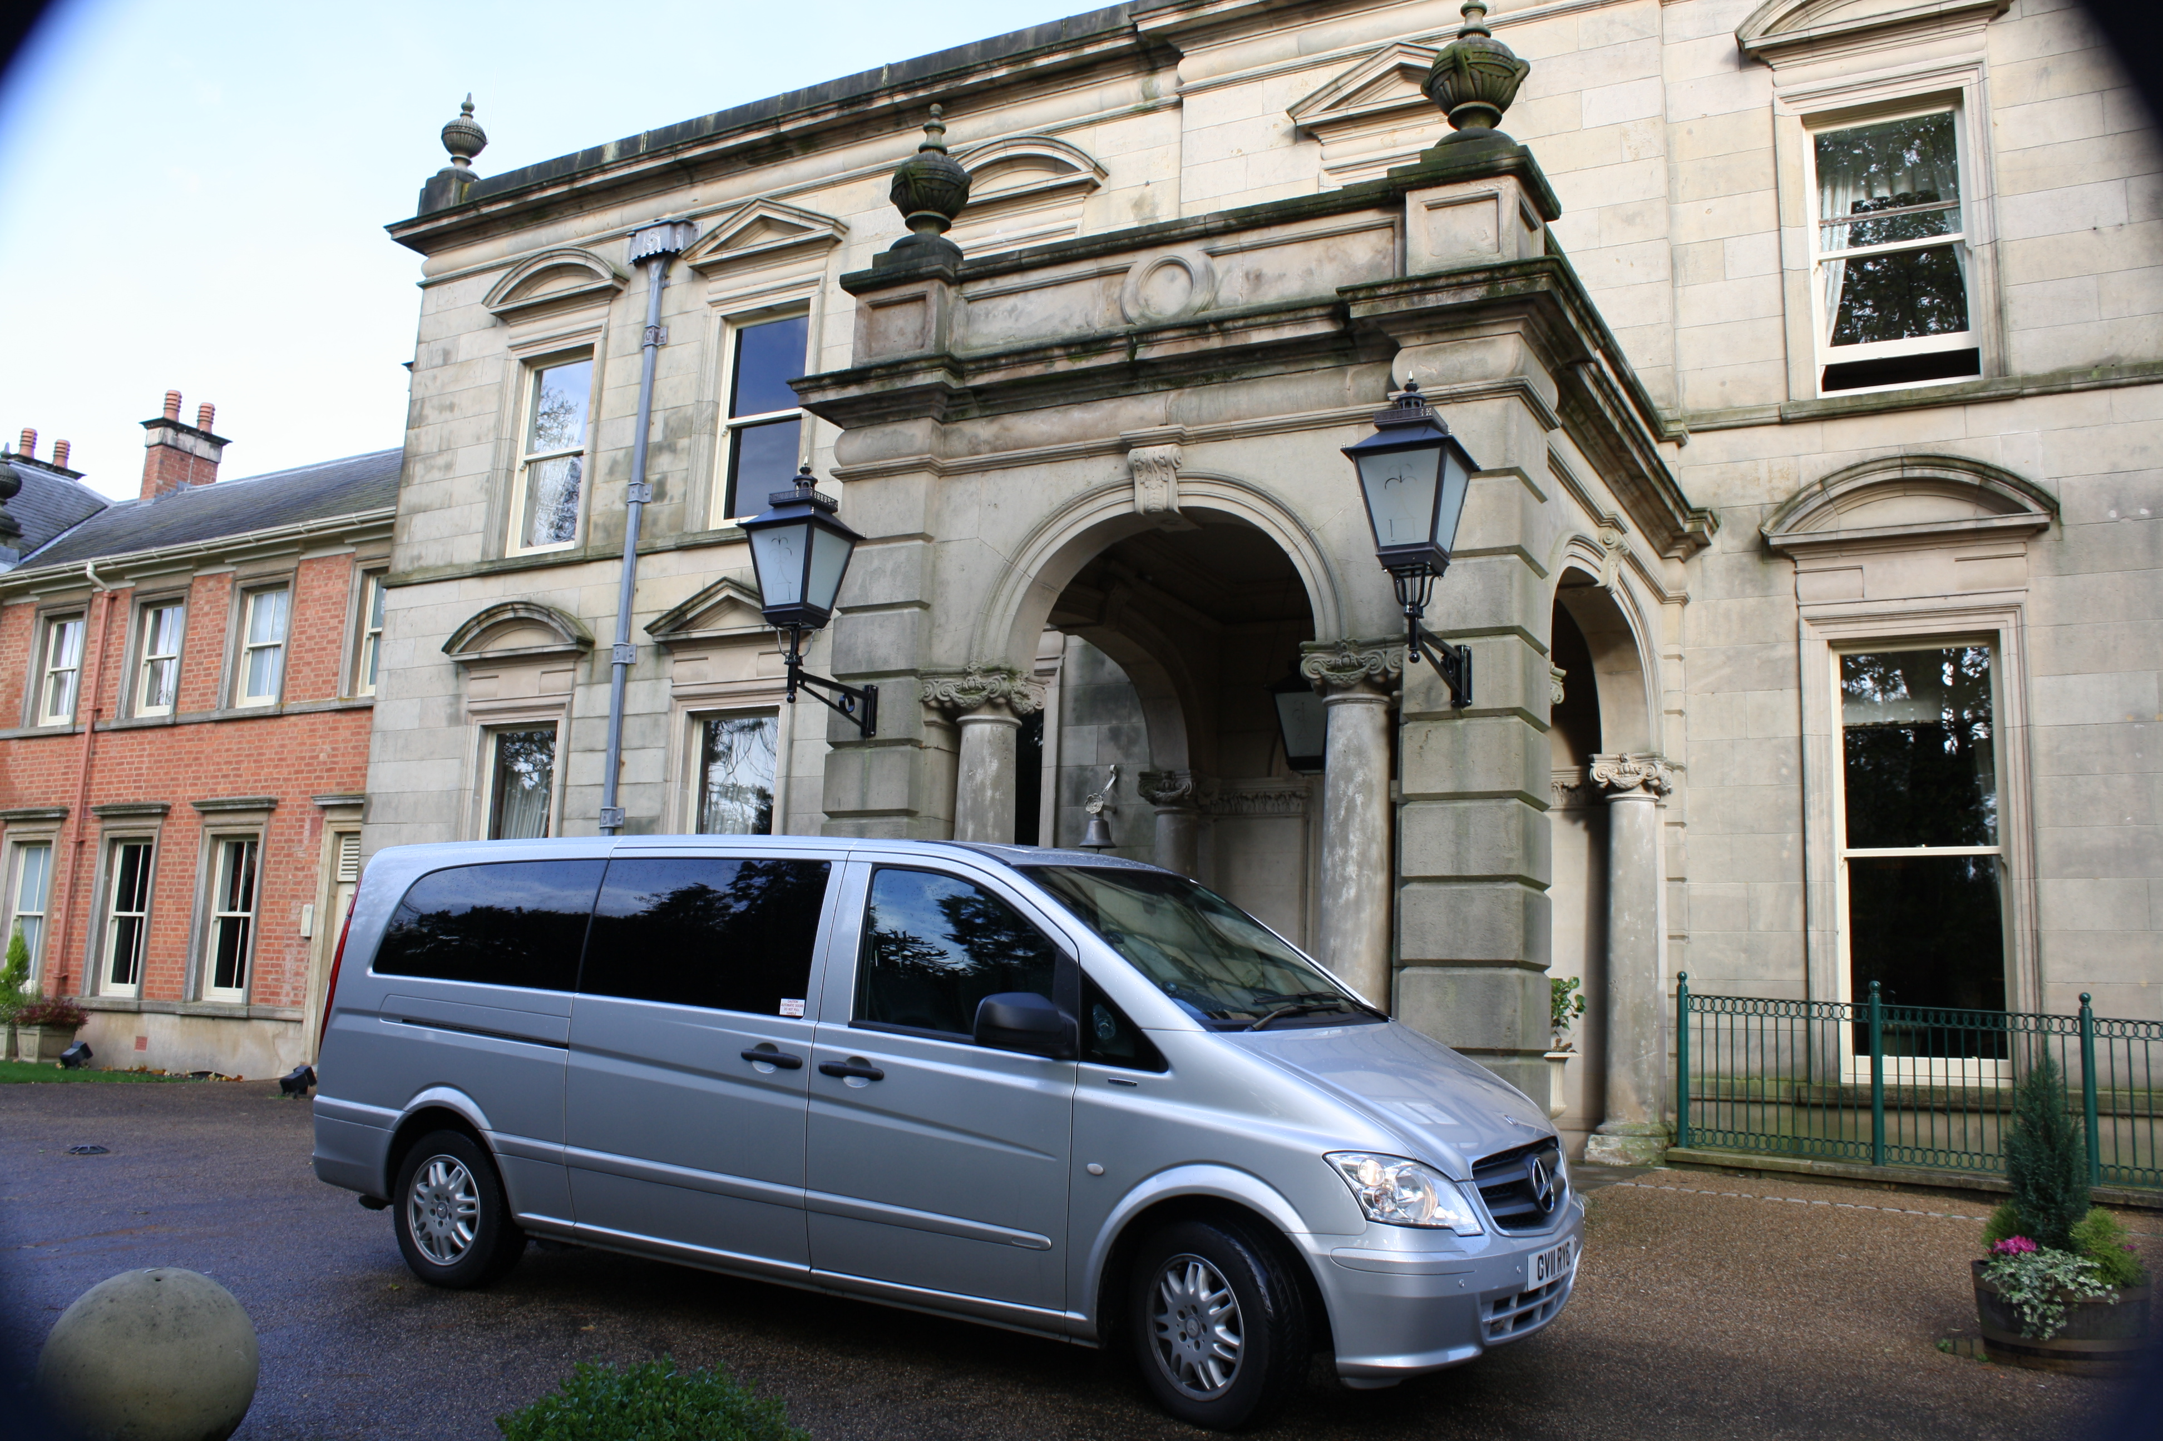
For
SALE
For further information please do not hesitate to contact us.
Unit 8
88 Bushey Road
London
SW20 0JH

Tel; +44 (0) 845 051 0111
Tel; +44 (0) 772 565 7688
Fax; +44 (0) 845 051 8999
Email; info@kcschauffeur.co.uk

- Leather Seats

- 8 Passenger Seats

- Fully Air Conditioned

- Extra Long Wheel Base

- Room for luggage

- For your comfort, bottled water and magazines
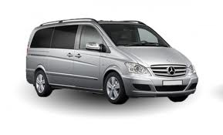
Kingsbridge Chauffeur & Minibus Services
We cater for a wide variety of events from corporate to tours and weddings. At KCS we have an exemplary customer service history due to our company policy;
‘It’s not just getting there, it’s how you Arrive.’

