**Scotland’s Premier Independent Chauffeur Company**

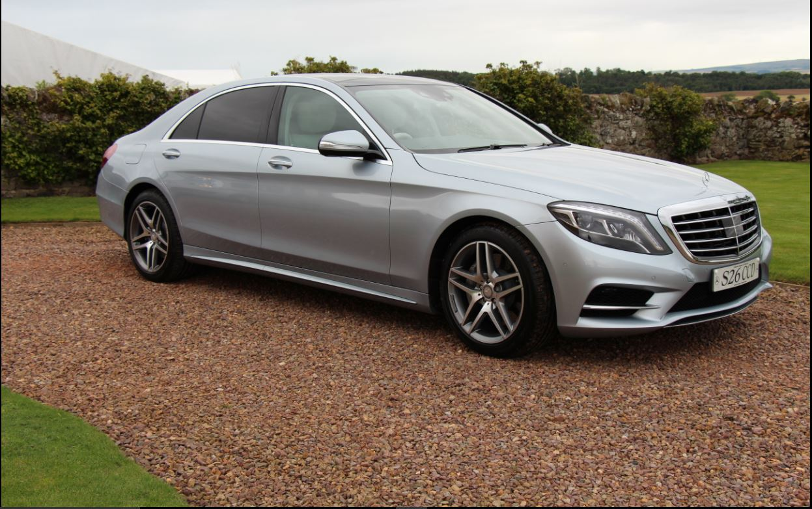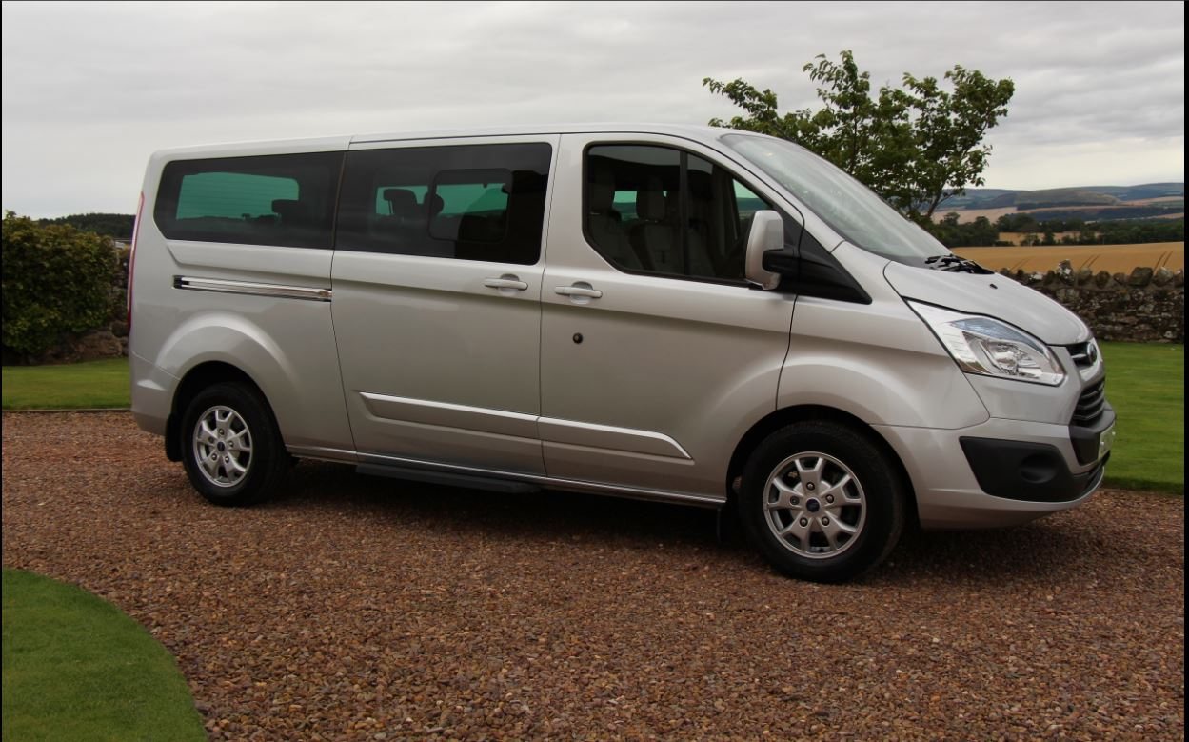 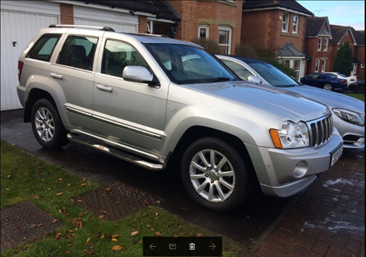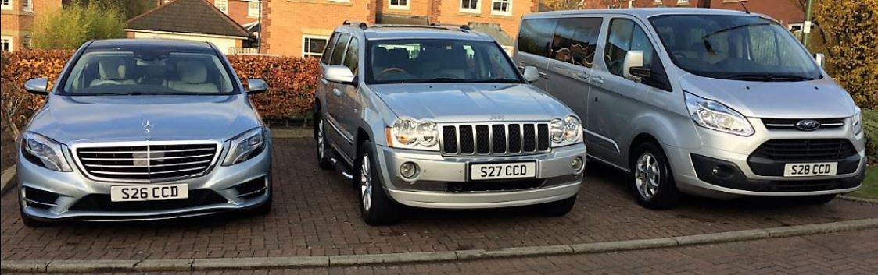

*Luxury Chauffeur Driven Tours of Scotland,*

*City Tours, Airport Transfers, Golfing Tours, Financial Roadshows, Sporting/Social Event Transfers, City to City Transfers, Wedding Cars, Evening Dining Transfers.*

2015 Mercedes S Class AMG LWB Limousine

2015 Ford Tourneo Custom ( Titanium Model ) 8 Passenger People Carrier

2010 Jeep Grand Cherokee Overland 4x4

Tel’+44(0)131 654 2200-Mb+44(0)7881 406 360

[info@eoscs.co.uk](mailto:info@eoscs.co.uk)-[www.achauffeur.com](http://www.achauffeur.com)